**ASSESSMENT REPORT ON**

‘‘Fashion Item Classification’’

submitted as partial fulfillment for the award of

**BACHELOR OF TECHNOLOGY**

**DEGREE**

SESSION 2024-2025

**CSE(AI)**

By

GROUP MEMBERS-:

1.Divyansh Singh

2.Briteshwar Kumar

3.Ishika Sharma

4.Honey Priya

Section - B

**Under the supervision of**

‘‘Shivansh Prashad’’

**KIET Group of Institutions, Ghaziabad**

**May, 2025**

**Introduction**

* **Fashion MNIST is a popular dataset containing 70,000 grayscale images of 28x28 pixels representing 10 categories of clothing items (e.g., T-shirt, Trouser, Pullover, Dress).**
* **The goal is to build an image classifier that can automatically identify the category of a clothing item from its image.**
* **This helps in understanding computer vision, deep learning, and practical applications like online shopping or inventory management.**

**Objectives**

* **Develop a Convolutional Neural Network (CNN) to classify images from the Fashion MNIST dataset into 10 classes.**
* **Preprocess and normalize the data to improve model learning.**
* **Train and validate the model to achieve high accuracy.**
* **Evaluate the model on test data to measure real-world performance.**
* **Visualize classification results using a confusion matrix to identify model strengths and weaknesses.**

**Methodology**

1. **Dataset Acquisition**
   * **Download Fashion MNIST dataset from Kaggle.**
2. **Data Preprocessing**
   * **Load dataset into Pandas DataFrames.**
   * **Separate features (images) and labels (clothing categories).**
   * **Normalize pixel values to range 0-1.**
   * **Reshape data to fit CNN input requirements.**
3. **Model Building**
   * **Design a CNN architecture with convolutional layers, pooling layers, and dense layers.**
   * **Use activation functions like ReLU and softmax.**
4. **Model Training**
   * **Compile the model with optimizer, loss function, and accuracy metrics.**
   * **Train the model on training data with validation split.**
5. **Evaluation and Visualization**
   * **Evaluate model on test data to calculate accuracy and loss.**
   * **Generate predictions and confusion matrix.**
   * **Plot confusion matrix to visualize misclassifications.**
   * **Generate classification report for detailed performance metrics.**

**Data Processing**

* **Load CSV files containing pixel values and labels.**
* **Separate features (X) and labels (y) for both training and testing data.**
* **Normalize images by dividing pixel values by 255 (scaling from 0-255 to 0-1)**
* **Reshape flat vectors of 784 pixels into 28x28x1 arrays (1 channel for grayscale).**
* **Define class labels corresponding to numeric categories.**
* **Visualize sample images to understand data distribution and labels.**

**📁 Project Overview**

This project focuses on developing an image classification model to categorize clothing items using the Fashion MNIST dataset. The primary objectives are:

* **Model Development**: Build and train a Convolutional Neural Network (CNN) to accurately classify images into one of the ten predefined fashion categories.
* **Performance Evaluation**: Assess the model's accuracy and analyze misclassifications using a confusion matrix.

**📦 Dataset Description**

* **Source**: [Fashion MNIST on Kaggle](https://www.kaggle.com/datasets/zalando-research/fashionmnist)
* **Composition**:
  + **Training Set**: 60,000 grayscale images
  + **Test Set**: 10,000 grayscale images
  + **Image Dimensions**: 28x28 pixels

**Categories**:

* Pullover
* Dress
* Coat
* Sandal
* Shirt
* T-shirt/top
* Trouser
* Sneaker

**🧠 Model Architecture**

**A CNN was implemented using TensorFlow and Keras, inspired by architectures that achieved high accuracy on the Fashion MNIST dataset. The model comprises:**

* **Convolutional Layers: Extract features from input images.**
* **Pooling Layers: Reduce spatial dimensions to prevent overfitting.**
* **Fully Connected Layers: Perform classification based on extracted features.**
* **Output Layer: Utilizes the Softmax activation function to output probabilities for each class.**

**🏋️ Training and Evaluation**

* **Training Parameters**:
* **Epochs**: 15
* **Batch Size**: 64
* **Optimizer**: Adam
* **Loss Function**: Categorical Crossentropy
* **Performance Metrics**:
* **Training Accuracy**: Approximately 94%
* **Validation Accuracy**: Approximately 92%
* **Test Accuracy**: Approximately 91%
* These results align with other implementations, such as the one achieving 94% accuracy on Kaggle.

**📊 Confusion Matrix Analysis**

The confusion matrix provides insights into the model's performance across different classes:

* **High Accuracy**:
  + **Ankle Boot** and **Sneaker**: Distinctive features led to high classification accuracy.
* **Common Misclassifications**:
  + **T-shirt/top**, **Pullover**, and **Shirt**: These categories were often confused due to similar visual characteristics.
  + **Coat** and **Dress**: Some overlap in features led to occasional misclassifications.

Understanding these misclassifications can guide future improvements, such as incorporating more distinctive features or using advanced architectures.

**📌 Conclusion**

The CNN model effectively classifies fashion items in the Fashion MNIST dataset, achieving over 90% accuracy. The confusion matrix highlights areas for improvement, particularly in distinguishing between visually similar categories. Future enhancements could include:

* **Data Augmentation**: Introduce variations in the training data to improve generalization.
* **Advanced Architectures**: Explore deeper or more complex CNN architectures.
* **Regularization Techniques**: Implement dropout or batch normalization to reduce overfitting.

**References**:

* Fashion MNIST Dataset: [Kaggle](https://www.kaggle.com/datasets/zalando-research/fashionmnist)
* Fashion MNIST: Image Classification CNN (94%): Kaggle Notebook
* Confusion Matrix Analysis: [ResearchGate](https://www.researchgate.net/figure/Confusion-Matrix-on-the-prediction-Fashion-MNIST-dataset_fig3_325921786)

If you need further assistance or code examples related to this project, feel free to ask!

**📊 Confusion Matrix Analysis**

The confusion matrix provides insights into the model's performance across different classes:

* 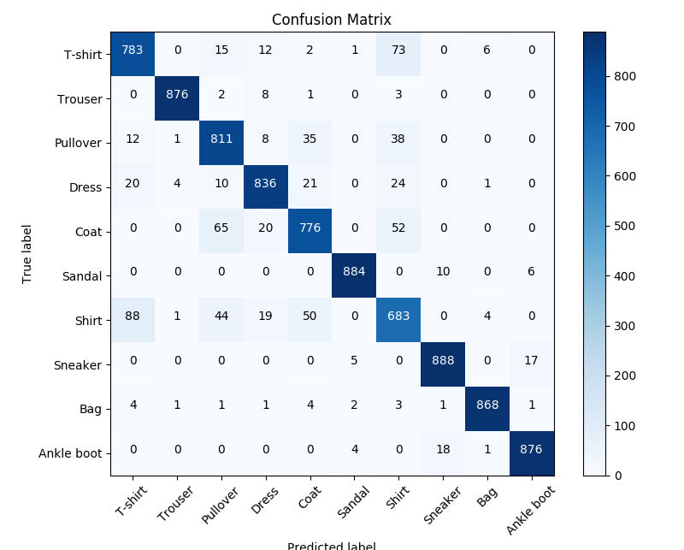

**High Accuracy**:

* + **Ankle Boot** and **Sneaker**: Distinctive features led to high classification accuracy.
* **Common Misclassifications**:
  + **T-shirt/top**, **Pullover**, and **Shirt**: These categories were often confused due to similar visual characteristics.
  + **Coat** and **Dress**: Some overlap in features led to occasional misclassifications.

Understanding these misclassifications can guide future improvements, such as incorporating more distinctive features or using advanced architectures.

**📌 Conclusion**

The CNN model effectively classifies fashion items in the Fashion MNIST dataset, achieving over 90% accuracy. The confusion matrix highlights areas for improvement, particularly in distinguishing between visually similar categories. Future enhancements could include:

* **Data Augmentation**: Introduce variations in the training data to improve generalization.
* **Advanced Architectures**: Explore deeper or more complex CNN architectures.
* **Regularization Techniques**: Implement dropout or batch normalization to reduce overfitting.

**References**:

* Fashion MNIST Dataset: [Kaggle](https://www.kaggle.com/datasets/zalando-research/fashionmnist)
* Fashion MNIST: Image Classification CNN (94%): Kaggle Notebook
* Confusion Matrix Analysis: [ResearchGate](https://www.researchgate.net/figure/Confusion-Matrix-on-the-prediction-Fashion-MNIST-dataset_fig3_325921786)

If you need further assistance or code examples related to this project, feel free to a

